

(ISO 9001:2015 Certified), Accredited with ‘A’ Grade by NAAC

🕿: 08258 - 281039 – 281263, Fax: 08258 – 281265

**Department of Computer Science and Engineering**

B.E. CSE Program Accredited by NBA, New Delhi from 1-7-2018 to 30-6-2021

–

**Report on Mini Project**

Minion Animation

**Course Code: 18CS607**

**Course Name: Computer Graphics Lab**

Semester: VI Section : C

**Submitted To:**

Mr. Puneeth R P

Asst Prof ,Dept of CSE,NMAMIT

**Submitted By:**

Name: Shashank USN: 4NM18CS165

Name: Saurav S Poojary USN: 4NM18CS161

**Date of submission:**

**Signature of Course Instructor**

**Abstract**

The main aim of this Mini Project is to illustrate the concepts and usage of pre-built functions in OpenGL. Creating Figures like minion and land and the surrounding environment using inbuilt functions provided by the glut library. The 2D environment is built in such a way to make it look like the minion is moving. We have menu and submenu options to interact with the program.

**MINION ANIMATION**

1. Introduction
2. Implementation details
3. Results
4. Conclusion
5. References

**INTRODUCTION**

Computer Graphics become a powerful tool for the rapid and economical production of pictures. There is virtually no area in which Graphical displays cannot be used to some advantage so it is not surprising to find the use of CG so widespread.

Although early application in engineering & science had to rely on expensive & cumbersome equipment, advances in computer technology have made interactive computer graphics a practical tool.

Computer Graphics in a diverse area such as science, engineering, medicine, business, industry, government, art, entertainment, education and training.

Now it can be answered about computer graphics as a generalized tool for drawing and creating pictures and simulates the real world situations within a small computer window.

Our project Minion Animation aims at bringing awareness about the current covid-19 pandemic through a simple animation. It is user interactive and includes several movements for the cartoon object named the minion.

We all have been affected by the current COVID-19 pandemic, there are several reasons for this. This project aims primarily on how the coronavirus may spread if you don’t protect yourself by following necessary precautions. This project concentrates on three minions. One minion is wearing a mask, one is not wearing a mask and the other one itself is a coronavirus. So we can see that one minion is following guidelines and the other not. So this project shows how the corona virus spreads the infection if you are not following guidelines.

**Implementation Details**

**Graphic library functions used:**

1 void glBegin(glEnum mode);

2 void glEnd( );

3 void glColor3f[ i f d ] (TYPE r, TYPE g, TYPE b);

4 void glClearColor(GLclampf r,GLclampf g,GLclampf b,GLclampf a);

5 int glutCreateWindow(char *title);

6 void glutInitWindowSize(int width, int height);

7 void glutInitWindowPosition(int x, int y);

8 void glutInitDisplayMode(unsigned int mode);

9 void glFlush( );

10 void glutInit (int argc, char **argv);

11 void glutMainLoop( );

12 void glutDisplayFunc(void (*func) (void));

13 gluOrtho2D(GLdouble left, GLdouble right, GLdouble bottom,GLdouble top);

14 void glutBitmapCharacter(void *font, int char);

15 void glClear(GL_COLOR_BUFFER_BIT);

16 void translate[fd](TYPE x,TYPE y,TYPE z);

17 void glPushMatrix(); void glPopMatrix();

18 void glLoadMatrix[fd](TYPE *m);

**User Defined functions used:**

1 void output(int x, int y, char *str);

2 void init();

3 void circle(int r,int s,int e);

4 void land();

5 void body(int mood);

6 void hair(int mood);

7 void specsframe(int mood) ;

8 void mouthhappy();

9 void hand(int mood);

10 void clothes(int mood);

11void eyes(int mood);

12 void legs(int mood);

13 void shoes(int mood);

14 void displayText();

15 void animation(int action);

16 void page1();

17 void display();

18 void flag_menu(int num);

**Code Snippets:**

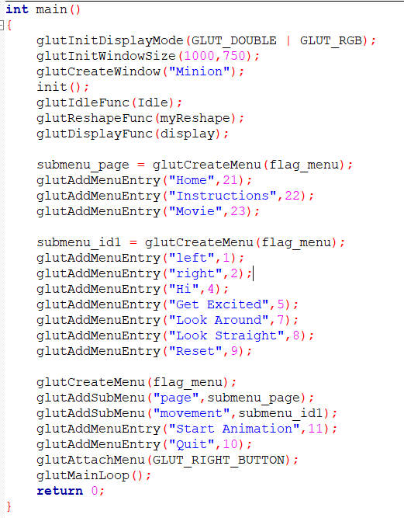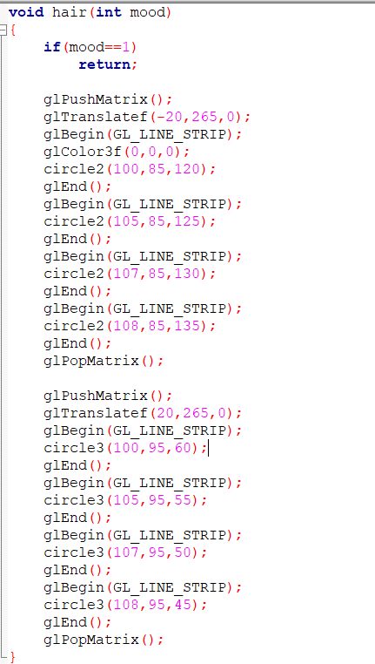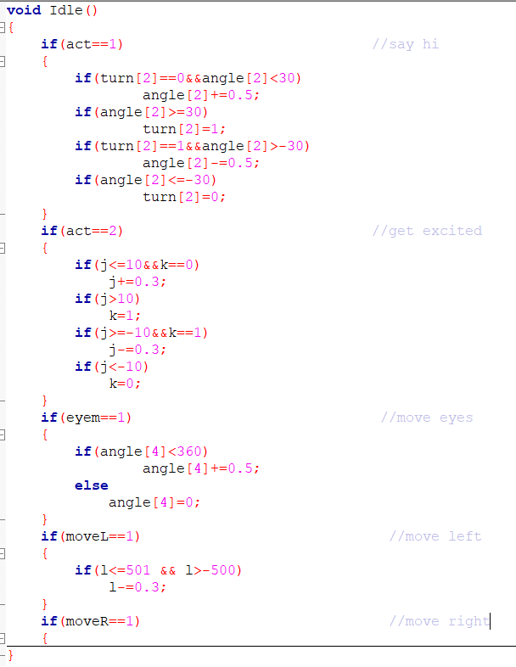

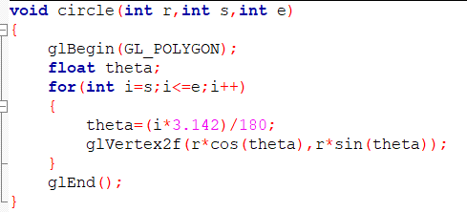

**Results**

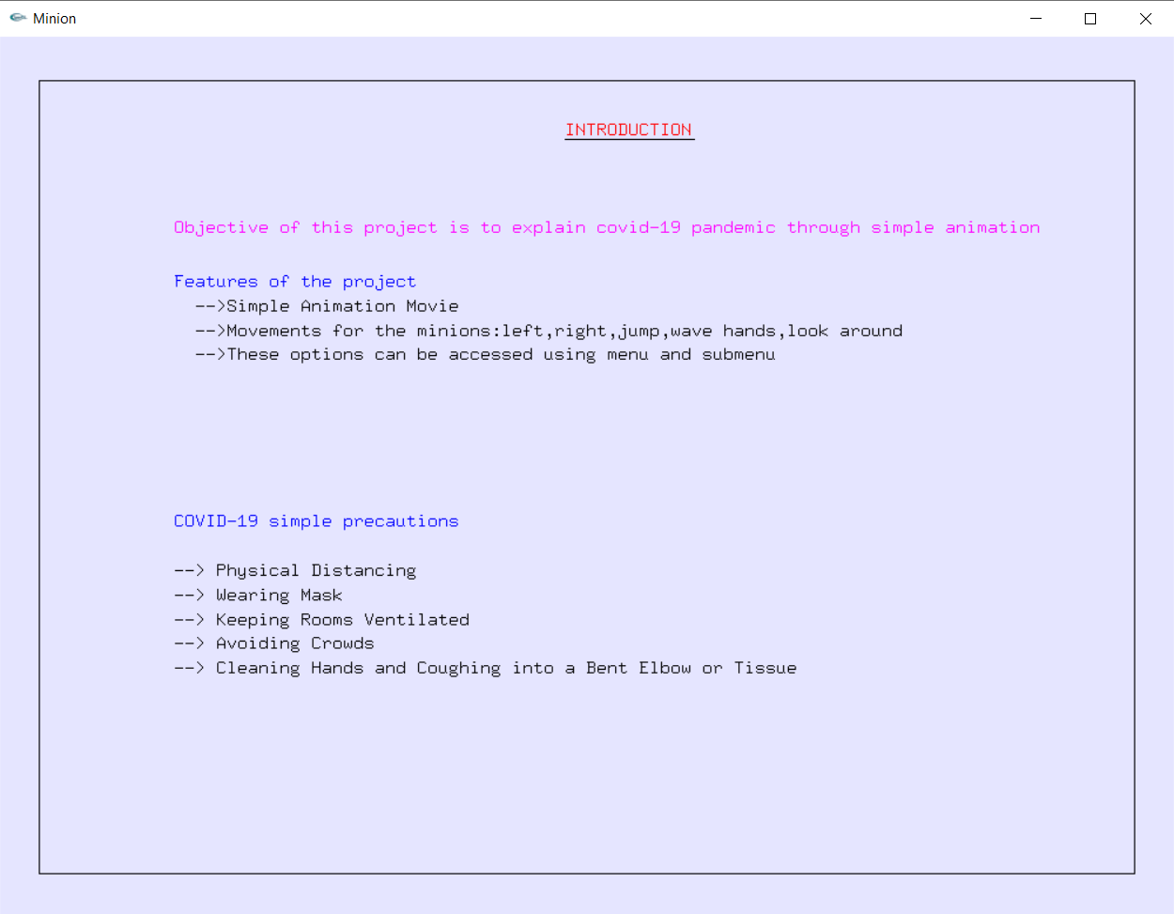

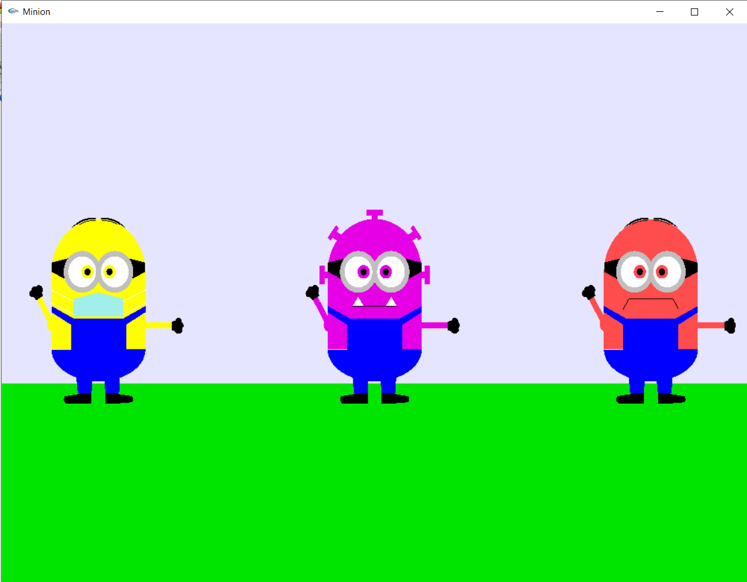

**CONCLUSION**

The project was started with a modest aim with no prior experience in OpenGL projects as this, but ended up in learning many things.

This is a simple interactive application. It is extremely user friendly and has the features, which makes a simple graphics project. It is open source and no security features have been included.

We found designing and developing this minion movie as a very interesting and learning experience. It helped us to learn about computer graphics, design of Graphical User Interfaces, interface to the user, user interaction handling and screen management.

**REFERENCES**

* <https://www.opengl.org/resources/>
* <https://stackoverflow.com>
* https://www.youtube.com/